Current System

1. Meetings with client. What were they about? What did he tell us to do?
2. Outline of current happenings in the project. Who’s doing what right now?
3. Training the AI image recognition. Explain how? Explain what images are being used and why?
4. In order to know what we as a group were to do, we had to meet with our client; John McGrath from IBM. We used Webex video meeting software to effectively speak with John to get an overall idea of the project and how we were to perform as a group.
5. We have all been assigned goals to fulfil before our next meeting, however the overall goal at this instant is to try and train the Visual Recognition AI from IBM Watson. We want the AI to be able to effectively and efficiently recognise certain objects and scenarios in images from the internet. To do this, we must let the AI analyse many images, some with the object we want it to recognise and some without. This will allow the AI to compare correct scenarios to incorrect scenarios, thus allowing it to learn.

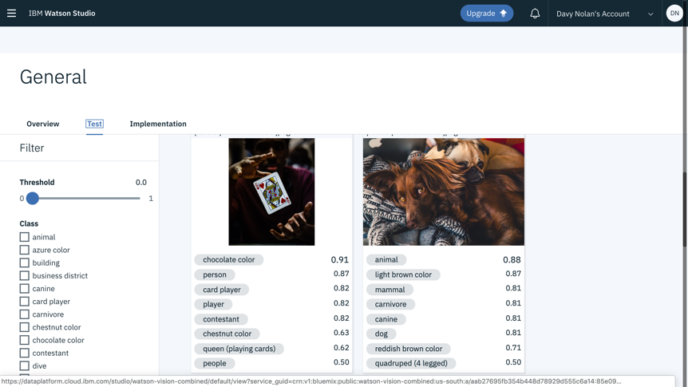

This screenshot shows the Watson Visual Recognition AI being tested for 2 images. Under each image the AI tries to generate tags that it can recognise in the image, however it may not be accurate. Our job now is to make the “tagging” more accurate for different scenarios.